Nintendo Sony would like to test the hypothesis that a difference exists in the average age of users of a Wii, a PlayStation, or an Xbox console game. The following data represent the age of a random sample of Wii, PlayStation, and Xbox users.

|  |  |  |
| --- | --- | --- |
| Wii | PlayStation | Xbox |
| 37 | 26 | 31 |
| 31 | 21 | 20 |
| 47 | 24 | 38 |
| 29 | 24 | 31 |
| 36 | 25 | 30 |

   
The grand mean for these observations is ________.

Interaction between two factors can be examined using

|  |  |  |
| --- | --- | --- |
|  |  | one-way ANOVA. |
|  |  | randomized block ANOVA. |
|  |  | two-way ANOVA. |
|  |  | either one-way or two-way ANOVA. |

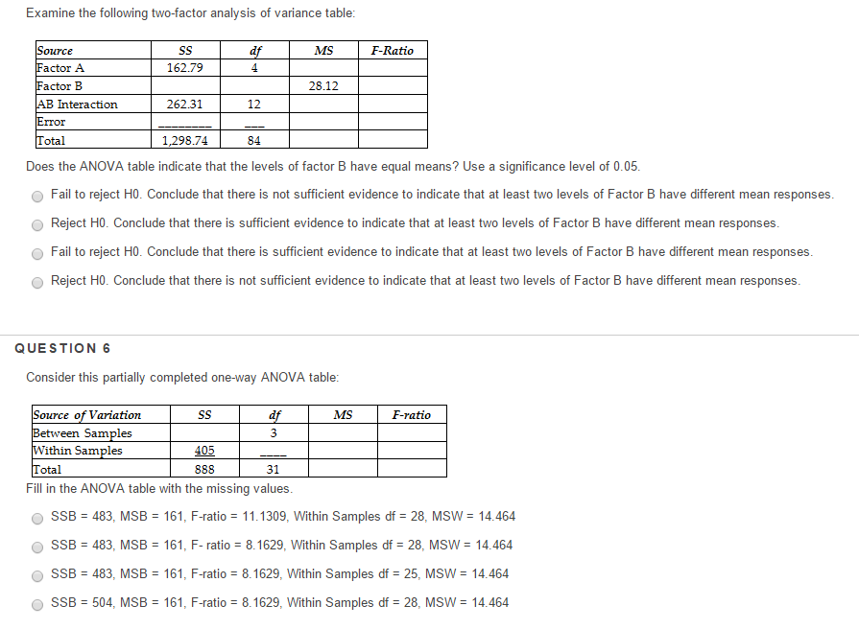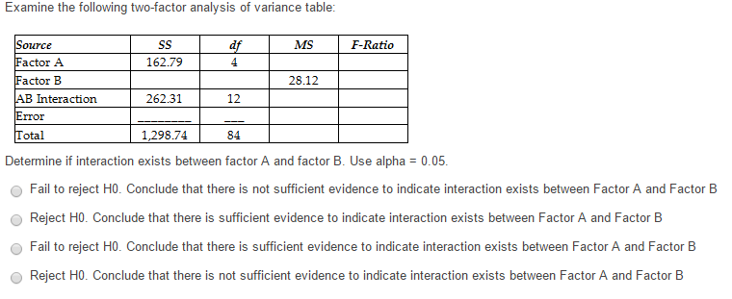

The sum of squares ________ measures the variation between the block means and the grand mean of the data in randomized block ANOVA.

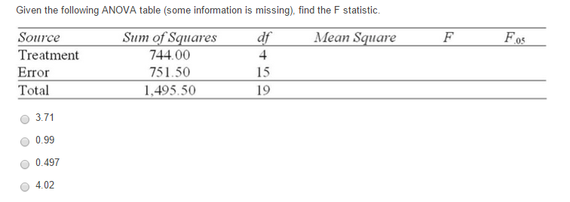

The variation attributable to factors other than the relationship between the independent variables and the explained variable in a regression analysis is represented by

|  |  |  |
| --- | --- | --- |
|  |  | regression sum of squares. |
|  |  | error sum of squares. |
|  |  | total sum of squares. |
|  |  | regression mean squares. |

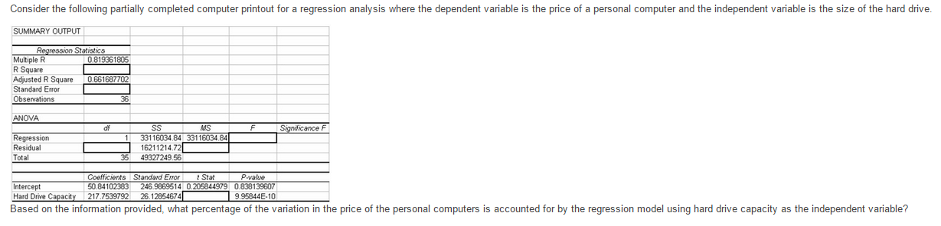

Based on the information provided, which of the following statements is true if alpha = .05?（harddrive case）

|  |  |  |
| --- | --- | --- |
|  |  | The slope is not significantly different from 0 because p-value = 0.84 is greater than 0.05 |
|  |  | The slope is significantly different from 0 because p-value = 9.95 is greater than 0.05 |
|  |  | The slope is not significantly different from 0 because p-value = 9.95 is greater than 0.05 |
|  |  | The slope is significantly different from 0 because p-value = 9.95E-10 is less than 0.05 |

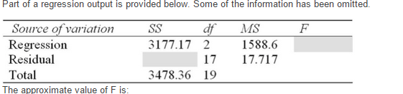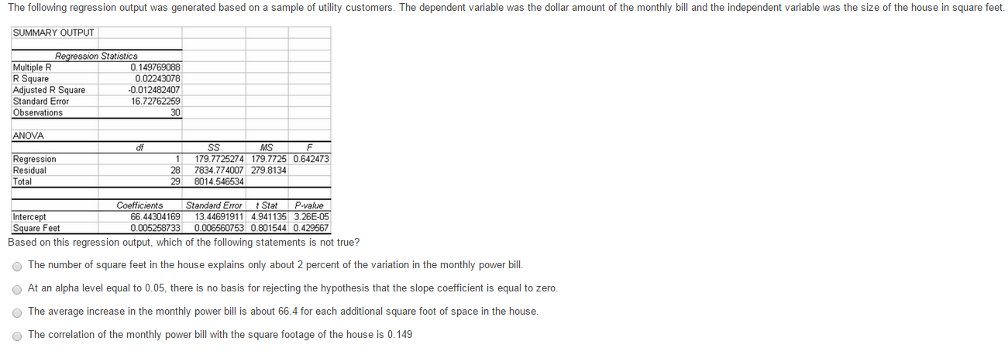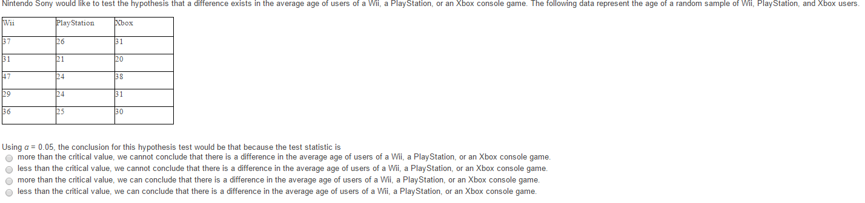

Using *α* = 0.05, the critical value for this hypothesis test would be ________.（sony case）

The critical value for a two-tailed test of H0: ß1 = 0 at a (alpha) = .05 in a simple regression with 22 observations is:

|  |  |  |
| --- | --- | --- |
|  |  | + or - 1.725 |
|  |  | + or - 2.086 |
|  |  | + or - 2.528 |
|  |  | + or - 1.960 |

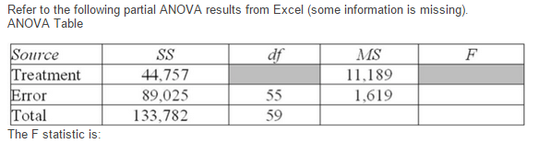

You decide to predict gasoline prices in different cities and towns in the United States for your term project.   Your dependent variable is price of gasoline per gallon and your explanatory variables are per capita income, the number of firms that manufacture automobile parts in and around the city, the number of new business starts in the last year, population density of the city, percentage of local taxes on gasoline, and the number of people using public transportation.  You collected data of 32 cities and obtained a regression sum of squares SSR= 122.8821. Your computed value of standard error of the estimate is 1.9549. What is the value of the coefficient of multiple determination?

|  |  |  |
| --- | --- | --- |
|  |  | 0.2225 |
|  |  | 0.4576 |
|  |  | 0.5626 |
|  |  | 0.6472 |
|  |  |  |

